REQUEST FOR QUALIFICATIONS
WITH REGARD TO THE DEVELOPMENT OF ALTERNATIVE GOVERNANCE OPTIONS FOR CONSIDERATION IN FUTURE VILLAGE TRUSTEE ELECTIONS
RFQ # 2017-02

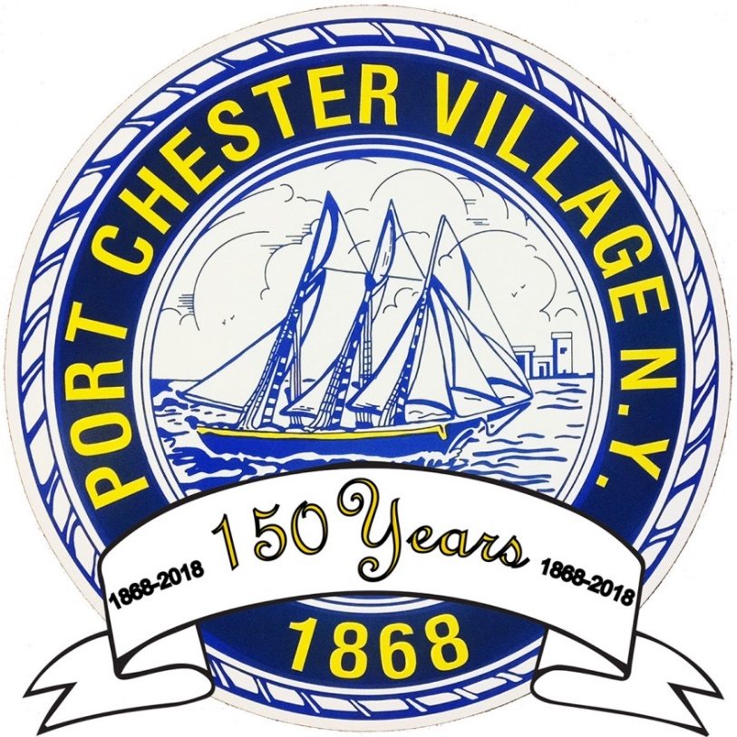

VILLAGE OF PORT CHESTER
BOARD OF TRUSTEES

Date: August 18, 2017

REQUEST FOR QUALIFICATIONS (RFQ # 2017-02)
VILLAGE OF PORT CHESTER
WITH REGARD TO THE DEVELOPMENT OF ALTERNATIVE GOVERNANCE OPTIONS FOR CONSIDERATION IN FUTURE VILLAGE TRUSTEE ELECTIONS

INTRODUCTION

BACKGROUND
Located in eastern Westchester County in the State of New York, the Village of Port Chester was the subject of litigation with the federal government brought in 2006. The complaint, brought in the United States District Court, Southern District of the State of New York, alleged that the Village’s electoral system for Trustee violated Section 2 of the Voting Rights Act. The government maintained that the method for electing the trustees as the governing board denied the Hispanic population of the Village an equal opportunity to participate in the political process and to elect representatives of their choice. A Hispanic resident, Cesar Ruiz, later intervened in the action.
The Village of Port Chester was incorporated by the State of New York in 1868 by special act of the State Legislature. It is generally governed by the special act which is known as the Village Charter. Port Chester is one of only 11 villages in the State that are governed by a charter and not the State Village Law. As a charter village, Port Chester has unique features of local law that are not shared by most other villages. Governance is one of them.
The Village Charter provides for a seven member Board of Trustees, a mayor and six trustees. The mayor has a two year term and is elected at large. The trustees have three-year terms and are also elected at large, and in a staggered manner so that each year two trustee seats are up. The Charter has since been amended by local law in 1975 to provide for a village manager form of government. The mayor is the presiding officer at Board meetings and can set the agenda, but he or she is of equal standing with the trustees and does not have the right to appoint village officers or veto any legislation.
The litigation resulted in a decision by the federal court in 2008 that held the Village liable for a Section 2 violation. The court directed the parties to make submissions with regard to an appropriate remedy. Under Section 2, the Village is presumptively entitled to the remedy of its choice. After further litigation, the court approved a consent decree in 2009 that imposed the Village’s remedy, cumulative voting, which would be used for the 2010, 2013 and 2016 Village Elections for Trustee. Cumulative voting is an election system that allows voters to cast as many votes as there are seats. However, unlike traditional winner-take-all systems, voters are not limited to giving only one vote to a candidate, they can cast multiple votes on one or more of the candidates. The consent decree provided for a comprehensive voter education program led by a coordinator employed by the Village. It also provided for other election procedures at variance from State Election Law such as early voting. The Village was also required to conduct exit polling for the 2010 Village Election.
Approximately 3,278 voters participated in the 2010 Village Election for Trustee, 3,134 in the 2013 Election for Trustee/Mayor and 2,589 in the 2016 Election for Trustee. In addition, approximately 2,711 voters participated in the Election for Mayor in 2011, 2,339 in 2015 and 2,028 in 2017.
The official population of the Village of Port Chester from the U.S. Census in 2000 was 27,867, and 2010 U.S. Census was 28,967. Based on the 2016 American Community Survey, the population was 29,524. Due to documented overcrowding issues, these counts are likely underreported.
The racial/ethnic background is as follows:
Race 2000 Census 2010 Census 2016 ACS

White 60.7% 61.1% 48.5%
Black/African American 7.0% 6.5% 5.8%
Hispanic or Latino 46.2% 59.4% 63.8%

(Total exceeds 100% due to duplicative self-reported data)

As of June 22, 2016, the consent decree expired thereby discharging the jurisdiction of the court.
Neither the federal government nor the intervenor brought any further proceedings against the Village. In fact, all parties have worked cooperatively throughout the implementation of the consent decree. Over the course of the consent decree, various addendums have executed to take into account technical issues of election administration. In each case, they were filed with the court on consent.
Pursuant to State Election Law, the Village transferred the conduct of the Village Election to the Westchester County Board of Elections.
Therefore, the Village is provided the opportunity to consider alternative governance options for future Village Trustee elections. The next Village Election is in March 2019 when all six trustee terms and the mayor’s term expire.
In October 2018, the Village must notify the County Board of Elections what offices will be in the 2019 Village Election. This is the first compliance deadline in the State Election Law calendar.

SCOPE OF WORK
The Village of Port Chester seeks qualified individuals, firm(s) and/or academic institutions to submit a statement of qualifications with regard to their specific credentials, experience and approach to the development of alternative governance options for consideration in future Village Trustee Elections.
The minimum qualifications required for a respondent shall include, at a minimum, the following:
- Demonstrated experience and ability to collect, analyze, and interpret large-scale voter records and election results at the local government level, including the calculation of the threshold of exclusion6

- Demonstrated experience and ability in working with census data to analyze Hispanic voting patterns;

- Knowledge, possession and experience in relevant computer software applications;

- Demonstrated experience and ability to develop, formulate, and make recommendations for specific local election systems;

- Demonstrated experience in facilitating compliance with state and Federal voter laws, such as the Voting Rights Act and New York State Election Law;

- Familiarity of case law, particularly remedies involving the Voting Rights Act ;

- Ability to support findings and conclusions as an expert witness.

- Such other subject-matter knowledge and expertise such that would fully inform the Village.
The purpose and intent of the Board of Trustees is to establish a sound, non-partisan and defensible method of electing Trustees that is accessible to voters, does not impose undue burden and expense to administer and encourages minority participation.

PROPOSAL CONTENTS
All qualified persons are invited to submit a proposal to this R.F.Q.. . Submission of a proposal indicates that the respondent has read and understands this entire R.F.Q. and that all concerns regarding this RFQ have been satisfied. Proposals must be submitted in the format described below. Proposals are to be prepared in such a way as to provide a straightforward, concise description of capabilities to satisfy the requirements of this RFQ. Proposals must be complete in all respects. A Proposal may not be considered if it is conditional or incomplete. All Proposals and accompanying materials submitted become the property of the Village of Port Chester.
      - Cover Page: Submit RFQ coversheet on letterhead stationery, signed by a duly authorized officer, employee, or agent of the consultant organization submitting the proposal that must include a statement that the proposal is submitted in response to Village of Port Chester RFQ #2017-02 Alternative Governance Options for Consideration in Future Village Trustee Elections.
      - Statement of Qualifications: Submissions should include detailed information regarding the respondent’s relevant education, employment history, consulting experience, background and any other information deemed relevant to the Village’s inquiry.
The Statement of Qualifications shall include, at a minimum, the following items:
- Resume.
- Proof of licensure ( if applicable)
- Work Samples
      - References: Provide two (2) references from employers and/or representative clients, with whom the proposer now works or has worked within the last five (5) years on a project similar in scope as that called for in this R.F.Q. In addition, provide the name of the entity, contact person, address, telephone number, project name, and dates the services were provided.

SUBMITTAL REQUIREMENTS
Responses should be transmitted to the Village of Port Chester at the following address:
Village of Port Chester
222 Grace Church Street
Port Chester, NY 10573
Attn: Janusz Richards, Village Clerk
Proposals must be submitted in a sealed envelope and have original signature and date. Please deliver one (1) original, nine (9) printed copies of the proposal. Please place a label on the envelope stating: “Village of Port Chester RFQ # 2017-02: Request for Qualifications with Regard to the Development of Alternative Governance Options for Consideration in Future Village Trustee Elections.

Due Date: All proposals must be submitted no later than September 8, 2017 at 10:00 a.m. in the office of the Village Clerk. Any proposals that are received after such date and time will not be considered.

EVALUATION

In evaluating qualifications submitted pursuant to this request, the Village of Port Chester places high value on the following factors, not necessarily in order of importance:

- Relevant experience.
- The general qualifications and experience of the staff proposed to be assigned to the engagement.
- Feedback from references.
- Overall organization, completeness, and quality of proposal, including cohesiveness, clarity of response and demonstrated understanding of the Village of Port Chester’s needs and time constraints.

ADMINISTRATIVE INFORMATION
- Submittal Requirements: Questions regarding this FRA should be directed in writing or email no later than August 31, 2017 to the following address: Written responses to questions will be provided on or before September 5, 2017.

Anthony M. Cerreto, Village Attorney
Village of Port Chester
222 Grace Church Street
Port Chester, NY 10753
Email: tcerreto@portchesterny.com

- Interviews: Certain respondents may be invited to present their proposal at a follow-up interview.

- Award: Following interviews, and a better understanding as to approach, scope of services and deliverables, the Village will release a Request for Proposals (R.F.P.) from a short list of the respondents to this R.F.Q.

The Village of Port Chester reserves its right to reject any and all proposals in the best interest of the Village.

The successful candidate must be ready, willing, and able to proceed and respond to the R.F.P. and sign an agreement satisfactory in form to the Village Attorney.

- Expenses Incurred by Responding Consultant: The Village of Port Chester is not responsible for any expenses or costs incurred in responding to this R.F.Q.

